

|  |
| --- |
| ELC001-2122EVESEM-I |
|  |
| Thapar University  Shivam Bhardwaj 102103420 |

# FEMUR

|  |
| --- |
| E-Commerce website Femur is a sample E-commerce website about buying dog care products online.  It has three major component which include :-   1. Welcome Page 2. Main User interface 3. Product Display |

The app was made with the help of flutter and VS code as a ide.

The component of app is shown in further pages

Welcome page

Consists of three slider images each with a button to main screen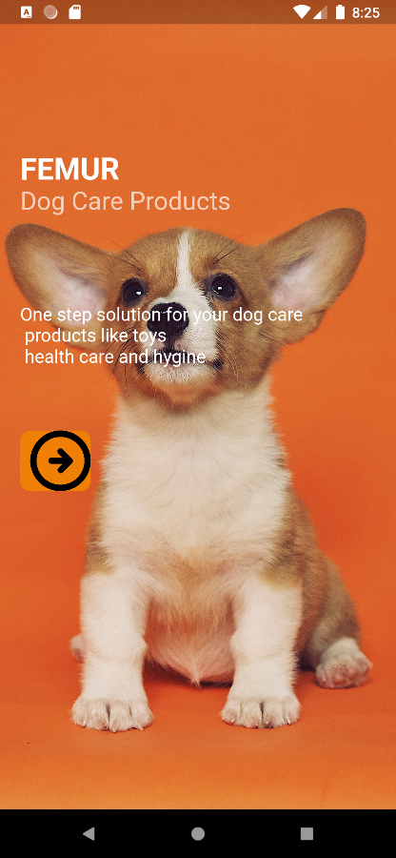 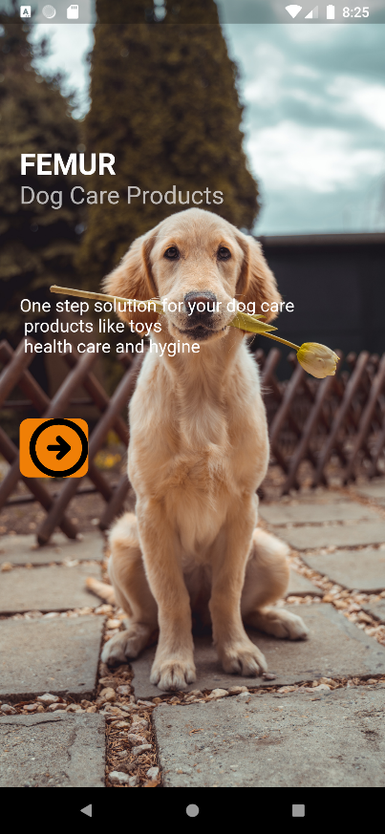



MAIN USER INTERFACE

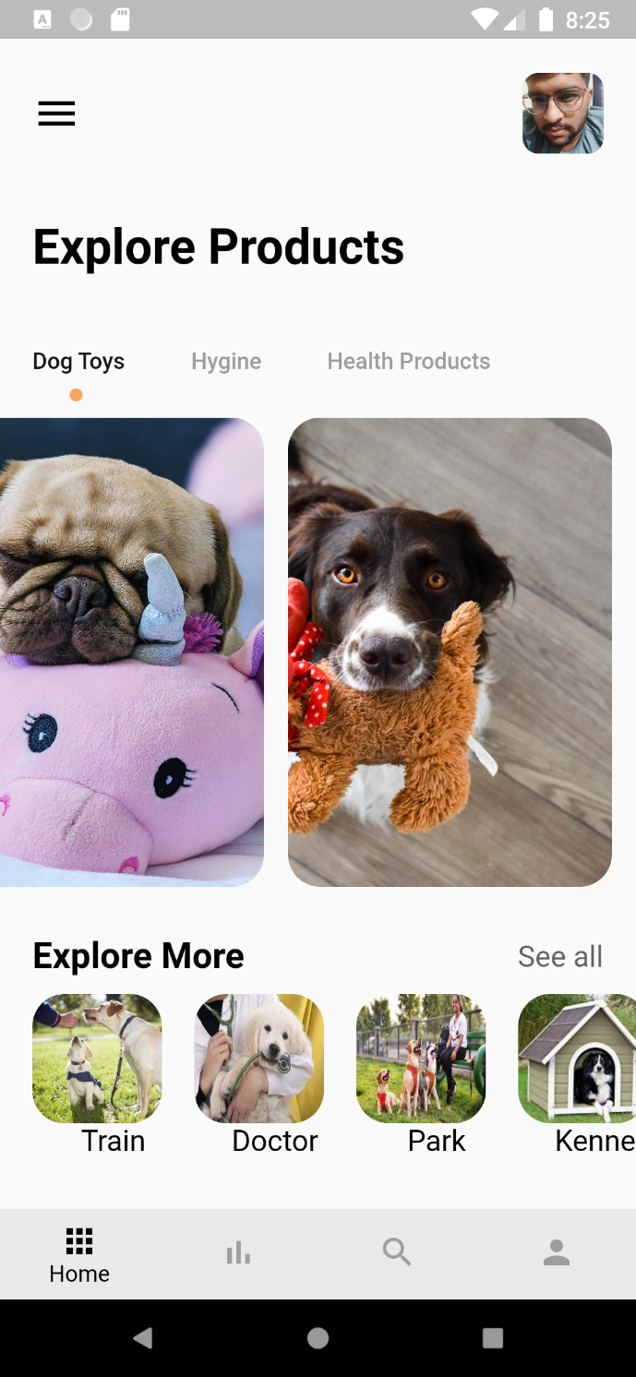

The main user interface had various sections starting from user profile, menu list, Explore Products which contains three sections for different range of products. By clicking on the image of product you will be diverted to product dart file.

The responsive bottom navigation bar container four sections for quick and easy user accessibility

PRODUCT DISPLAY

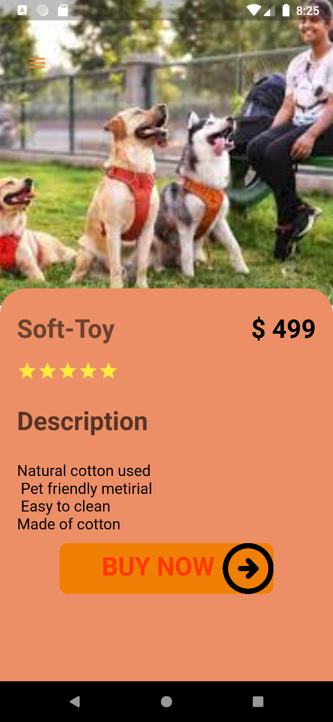This is the product details page which showed the product name, image, price, customer ratings and description about the product.

